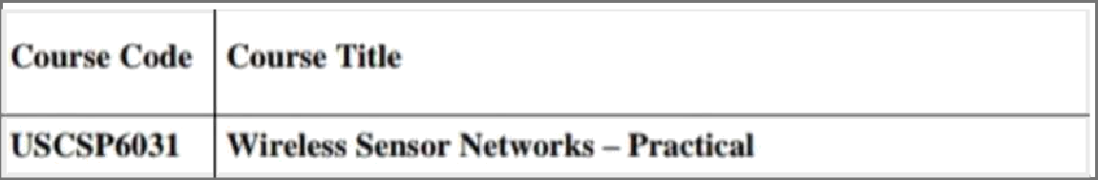

|  |
| --- |
| Understanding the Scnnor Nude Hardware. (For Eg. Sensors, Nodes(Sen.sor mute J, Base Staiion,Graphictd U•›cr Interface.1  $ Create un4 simulate c ximpIc adhoc network   1. Understanding, Reading and Analyzing Routing Table of n netwmk. 2. Create a biisic MANET implemcniaiion simulaiion for Packer aninuiiion and Packer Trace   $ Implement a Wireless sensor network simulation.  6 Create MAC protocol simulation implementation (or wireless stnsur Network. |
| 7 Simulate Mobile Adhoc Network with Directional Antenna |
| g Crcu‹e u mcbilc network uxing Cell Tower, Central Office Server, Web bruwwr and  Web Servcr. Simulate connection between them |

### Practical – 1

**Aim: Understanding the Sensor Node Hardware. (For Eg. Sensors, Nodes(Sensor mote), Base Station, Graphical User Interface.)**

### 1. Components

A wireless sensor network (WSN) is a hardware and software package that typically consists of four parts (see Figure 1):

1. *‘Sensors’* connected to each node by a wired connection. In our case, we use sensors that can measure soil moisture, electrical conductivity, soil temperature, water pressure, flow rate, or a range of weather variables (light, air temperature, wind, humidity, etc.).

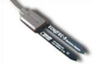

*Figure 2. One of many sensors that can be connected to a node, this EC-5 sensor (Decagon Devices, Inc. Pullman, WA) measures volumetric water content (soil moisture).*

1. *‘Nodes’* collect the data from sensors and transmit that to a ‘base station’

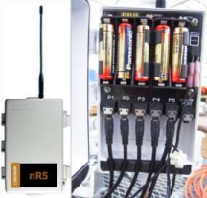computer using a one way (in the case of monitoring) or two-way (in the case of monitoring and control) radio. Nodes can simply monitor environmental and soil conditions or can be used to make control decisions. For example, some nodes have the capability to an electric valve, such as an

*Relay switch,*

*used to* irrigation valve.

*control irrigation valve(s), located here.*

*Figure 3. This nR5 (Decagon Devices, Inc. Pullman, WA) node is powered off of 5-AA batteries and is connected to 5 soil moisture sensors via stereo ports. The nR5 node is also capable of controlling irrigation valve(s), based on*

*user-defined settings.*

1. *‘Base Station’ computer* connects the system to the internet, so that data collected by the nodes, then transmitted to the base station computer, can be viewed anywhere an internet connection is available.
2. *‘Graphical User Interface’* is the web-based software package, that allows the data collected by sensors to be viewed. The software is also used to set irrigation parameters.

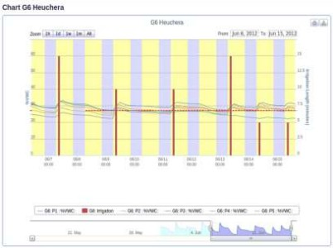

*Figure 4. The graphical user interface above depicts the volumetric water content (soil moisture) as*

*horizontal lines and irrigation events and amounts as bars. Notice the increase in soil moisture after each irrigation event.*

*Not every WSN will have all four components, but to get optimal functionality the systems developed as part of this project do.*

A very simple WSN example that many can relate to is that of the wireless environmental monitoring system used by the National Weather Service (NWS). You have probably seen these at a local airport or school. In this

case, sensors measure environmental conditions and send this data to a node that wirelessly transmits the data using a cell signal or wireless signal to a base-station computer where NWS employees (and you) can view the current temperature (or rainfall/dew point, wind, etc.) via a website or application (‘app’).

02

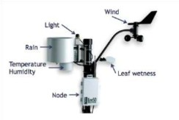

*Figure 5. Typical environmental monitoring sensors that you would see at a National Weather Service (NWS) monitoring station. These same components can be used in a wireless sensor network by a specialty crop producer.*

# Create and simulate a simple ad hoc network

## Aim:

To create a simple ad hoc network and perform its simulation with the required number of hosts

## Software Used:

Omnetpp 5.7, INET 4.3.6 framework

## Theory:

An ad hoc network is one that is spontaneously formed when devices connect and communicate with each other.

Ad hoc networks are mostly wireless local area networks (LANs).

The devices communicate with each other directly instead of relying on a base station or access points as in wireless LANs for data transfer co-ordination.

Each device participates in routing activity, by determining the route using the routing algorithm and forwarding data to other devices via this route.

## Types of Wireless Ad Hoc Networks

Wireless ad hoc networks are categorized into classes. Here are a few examples:

* 1. Mobile ad hoc network (MANET): An ad hoc network of mobile devices.
  2. Vehicular ad hoc network (VANET): Used for communication between vehicles. Intelligent VANETs use artificial intelligence and ad hoc technologies to communicate what should happen during accidents.
  3. Smartphone ad hoc network (SPAN): Wireless ad hoc network created on smartphones via existing technologies like Wi-Fi and Bluetooth.
  4. Wireless mesh network: A mesh network is an ad hoc network where the nodes communicate directly with each other to relay information throughout the network.
  5. Army tactical MENT: Used in the army for "on-the-move" communication, a wireless tactical ad hoc network relies on range and instant operation to establish networks when needed.
  6. Wireless sensor network: Wireless sensors that collect everything from temperature and pressure readings to noise and humidity levels can form an ad hoc network to deliver information to a home base without needing to connect directly to it.
  7. Disaster rescue ad hoc network: Ad hoc networks are important when disaster strikes and established communication hardware isn't functioning properly.

**Limitations of Ad Hoc Wireless Network**

1. For file and printer sharing, all users need to be in the same workgroup, or if one computer is joined to a domain, the other users must have accounts on that computer to access shared items.
2. Other limitations of ad hoc wireless networking include the lack of security and a slow data rate. Ad hoc mode offers minimal security; if attackers come within range of your ad hoc network, they won't have any trouble connecting.

Prof Ismail H. Popatia Page 1

We create an Ad hoc network with 7 hosts using Omnetpp and INET through the following steps

Step 1: Start the Omnetpp simulator through the following procedure Click on the file mingwenv

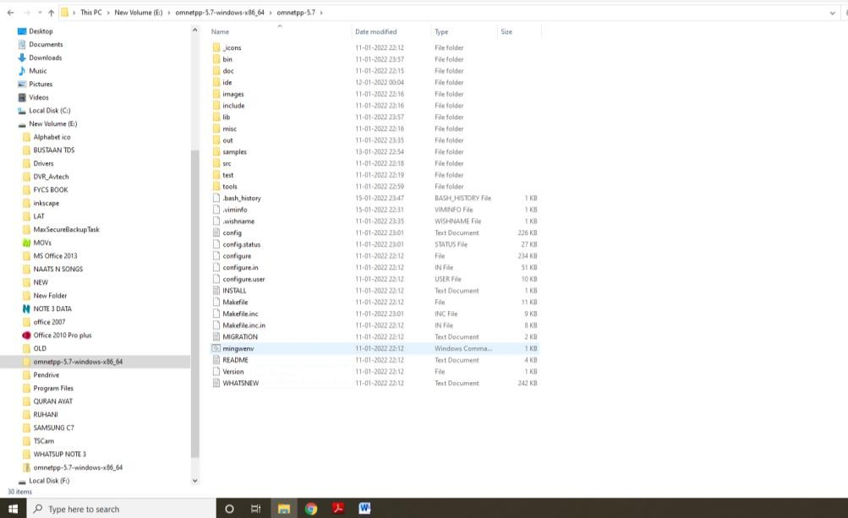

We will get the following $ prompt, type omnetpp and enter

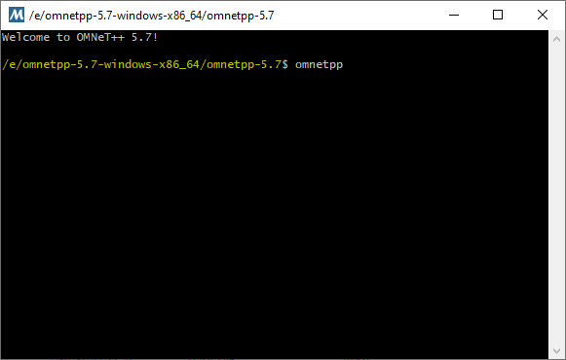

Prof Ismail H. Popatia Page 2

Step 2: The omnetpp simulator in now ready with the following user interface

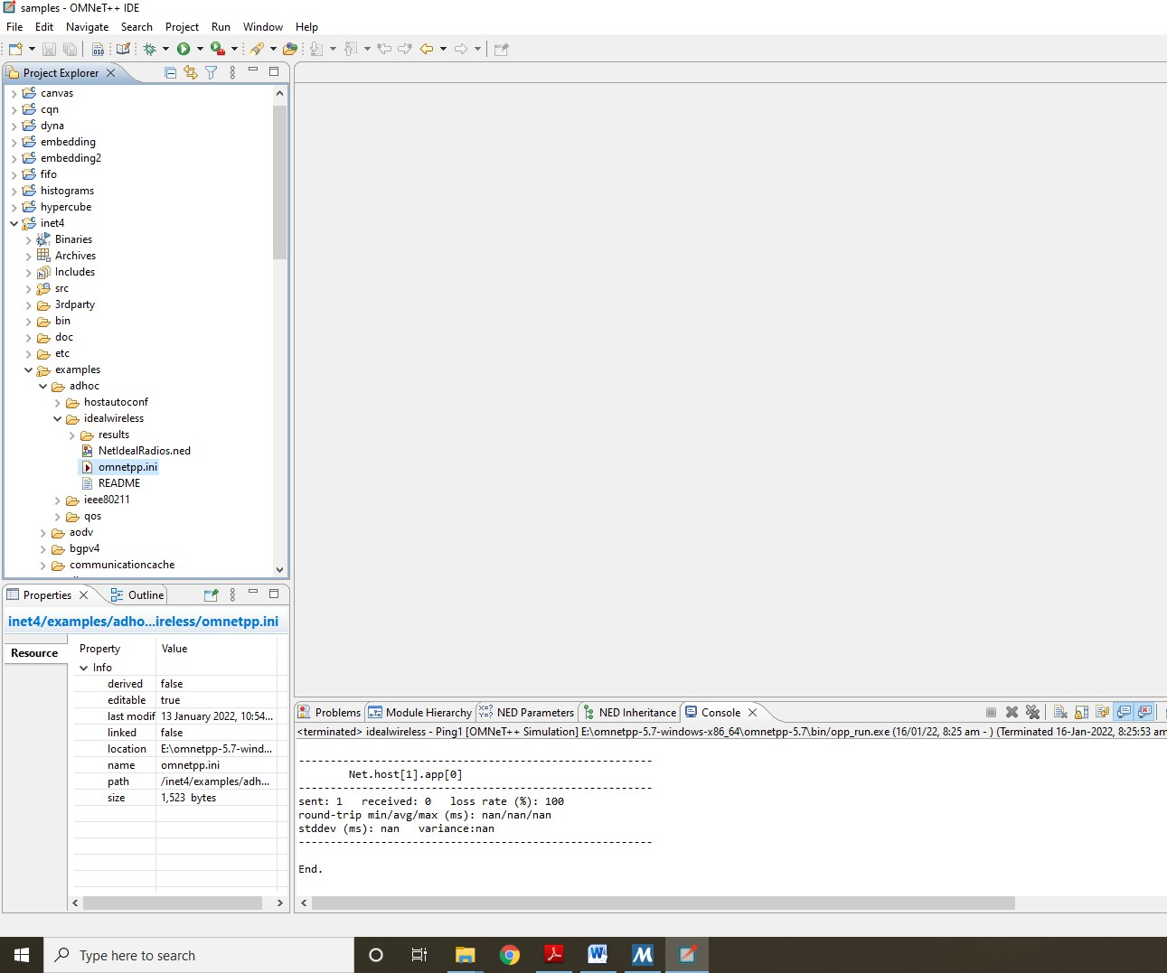

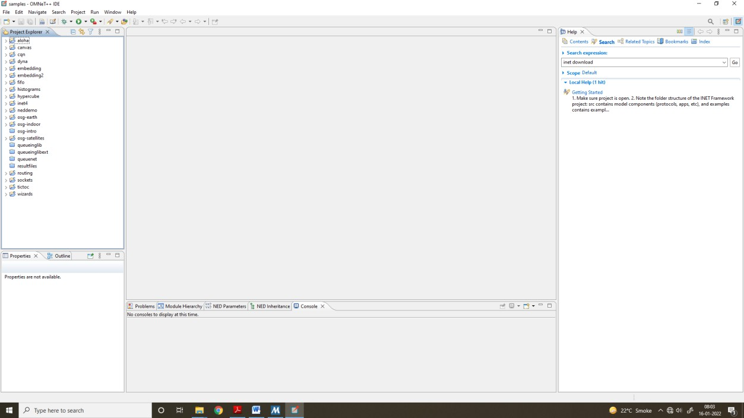

Click on inet folder, then in it click on examples, then on adhoc and then on idealwireless as given

Prof Ismail H. Popatia Page 3

Step 3: In order to load the simulation, double click on two files NetIdealRadios.ned and omnetpp.ini

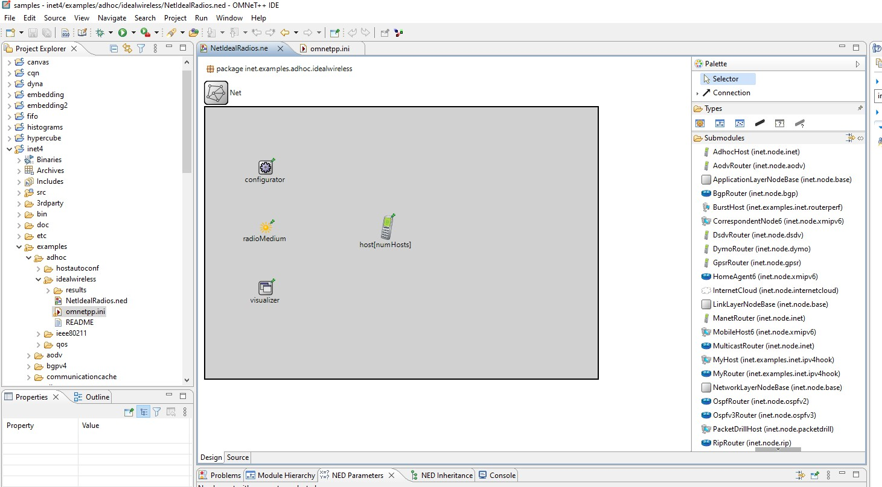

Step 4: Now we run the simulation

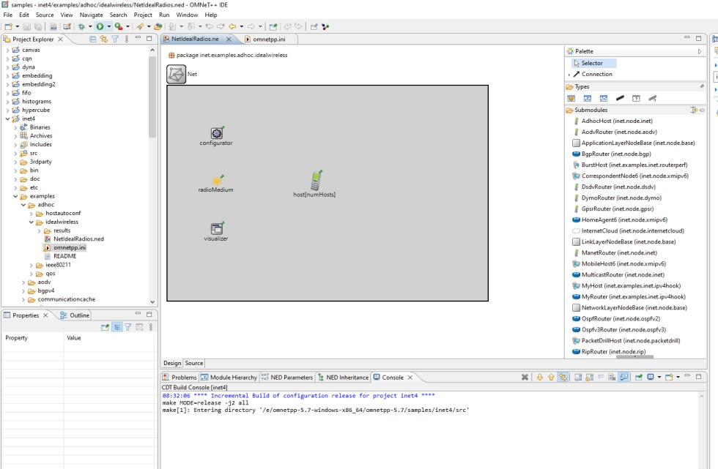

Prof Ismail H. Popatia Page 4

Step 5: After running the simulation we get the following

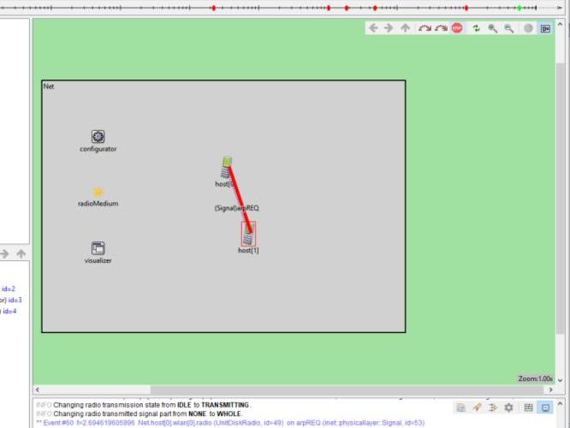

The number of hosts can be increased by the following

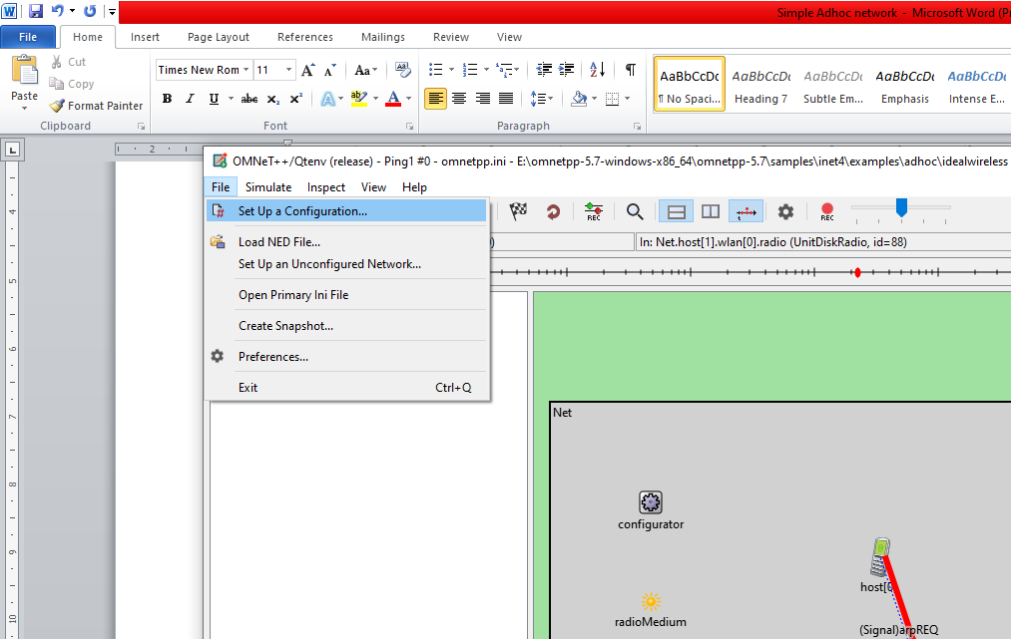

In this we get a dropdown menu, select n host option and enter the required hosts The following simulation has 7 hosts

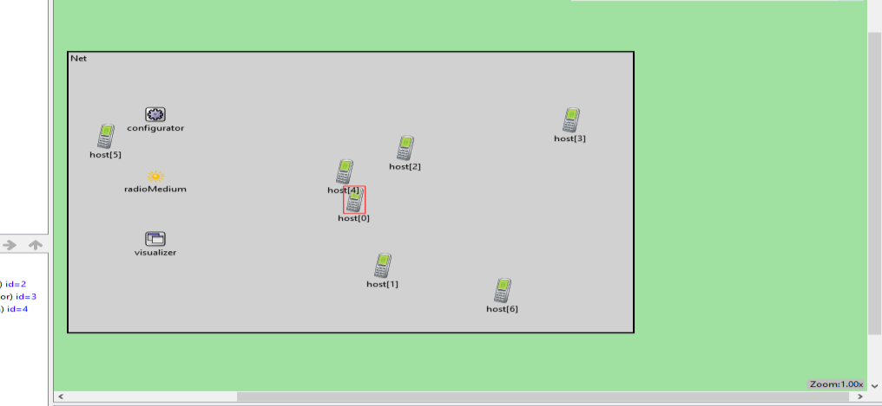

Prof Ismail H. Popatia Page 5

**Practical 3**

**Aim: Understanding, Reading and Analyzing Routing Table of a network. Steps:**

1. Open Cisco Packet Tracer and create the network as shown.

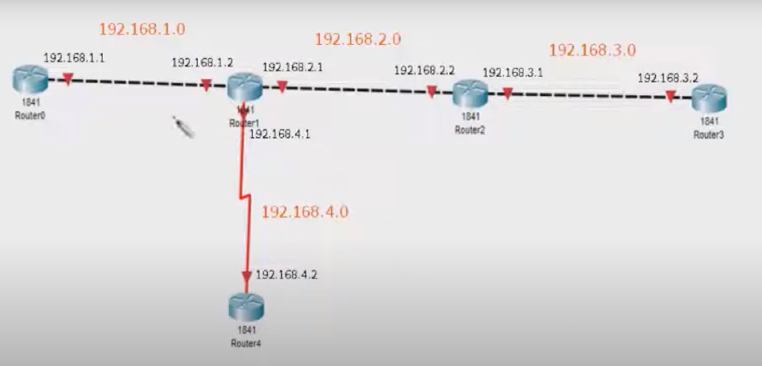

1. Click on Router 0,1,2,3,4 and make changes in the configuration tab. Add Serial port(WIC-22T) in Router 1 and Router 4 and connect it.
2. Configure RIP in all Routers

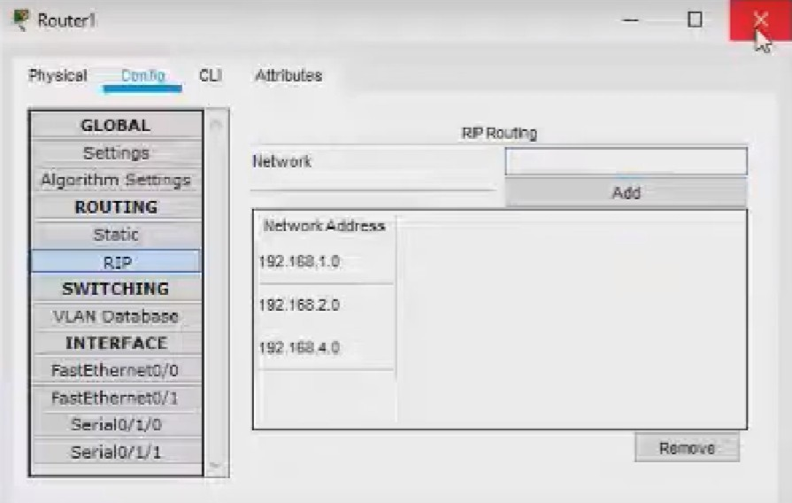

1. Click on Router 1. From the following tab click on CLI and analyze the network by show ip route command

**Output:**

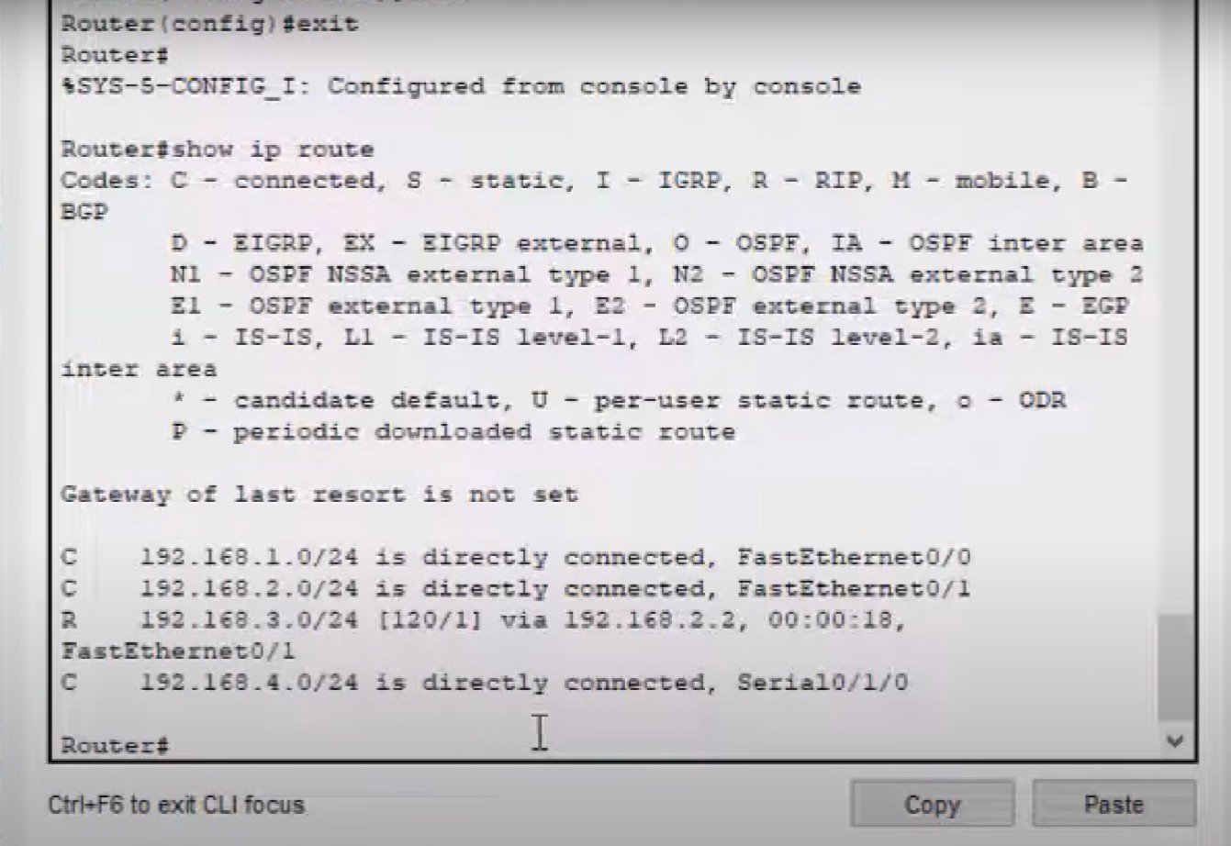

# MANET implementation simulation

## Aim:

To create a basic MANET implementation simulation for Packet animation and Packet Trace

## Software Used:

Omnet++ 5.7, INET 4.3.6 framework

## Theory:

* 1. MANET (Mobile Adhoc NETwork) also called a wireless Adhoc network or Adhoc wireless network that usually has a routable networking environment on top of a Link Layer ad hoc network
  2. They consist of a set of mobile nodes connected wirelessly in a self-configured, self- healing network without having a fixed infrastructure.
  3. MANET nodes are free to move randomly as the network topology changes frequently.
  4. Each node behaves as a router as they forward traffic to other specified nodes in the network.
  5. MANET may operate a standalone fashion or they can be part of larger internet.
  6. They form a highly dynamic autonomous topology with the presence of one or multiple different transceivers between nodes.
  7. The main challenge for the MANET is to equip each device to continuously maintain the information required to properly route traffic.

## The following are some of the important characteristics of MANET

1. Dynamic Topologies
2. Bandwidth constrained, variable capacity links:
3. Autonomous Behavior:
4. Energy Constrained Operation:
5. Limited Security:
6. Less Human Intervention:

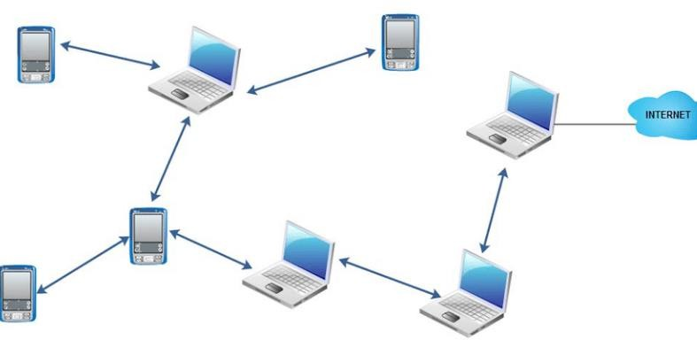

A Typical example of MANET

Prof Ismail H. Popatia Page 1

We create an MANET using Omnet++ and INET through the following steps Step 1: Open the Omnet++ software and click on inet4 folder

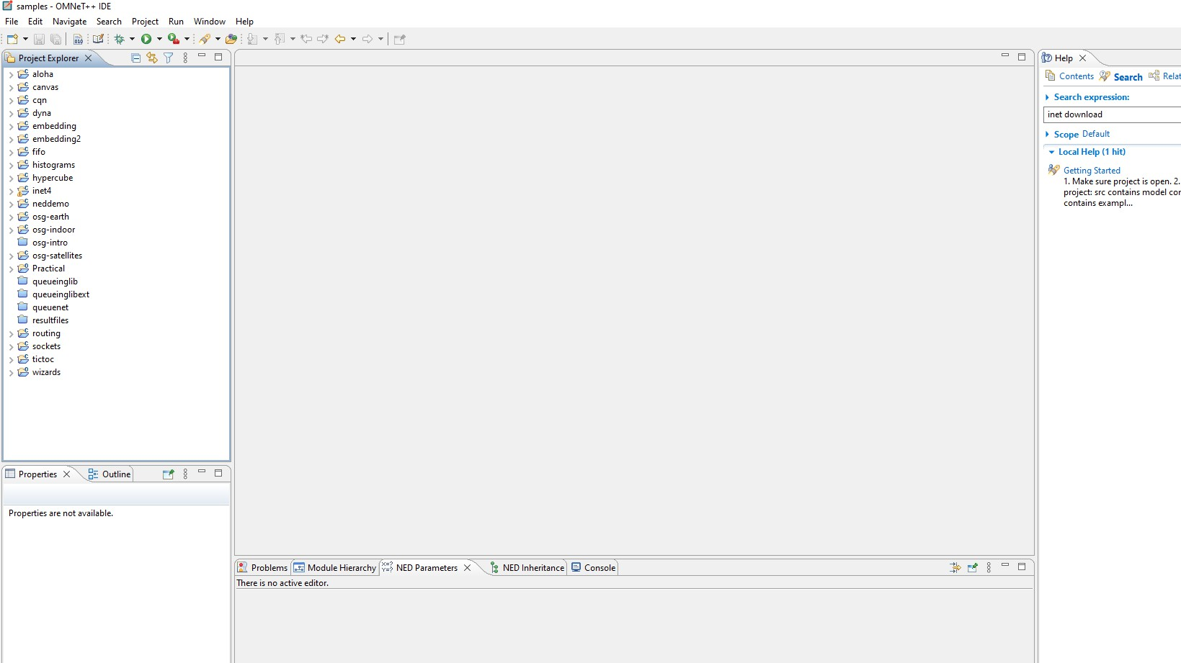

Step 2: Now select the examples folder and then in that folder select manetrouting folder

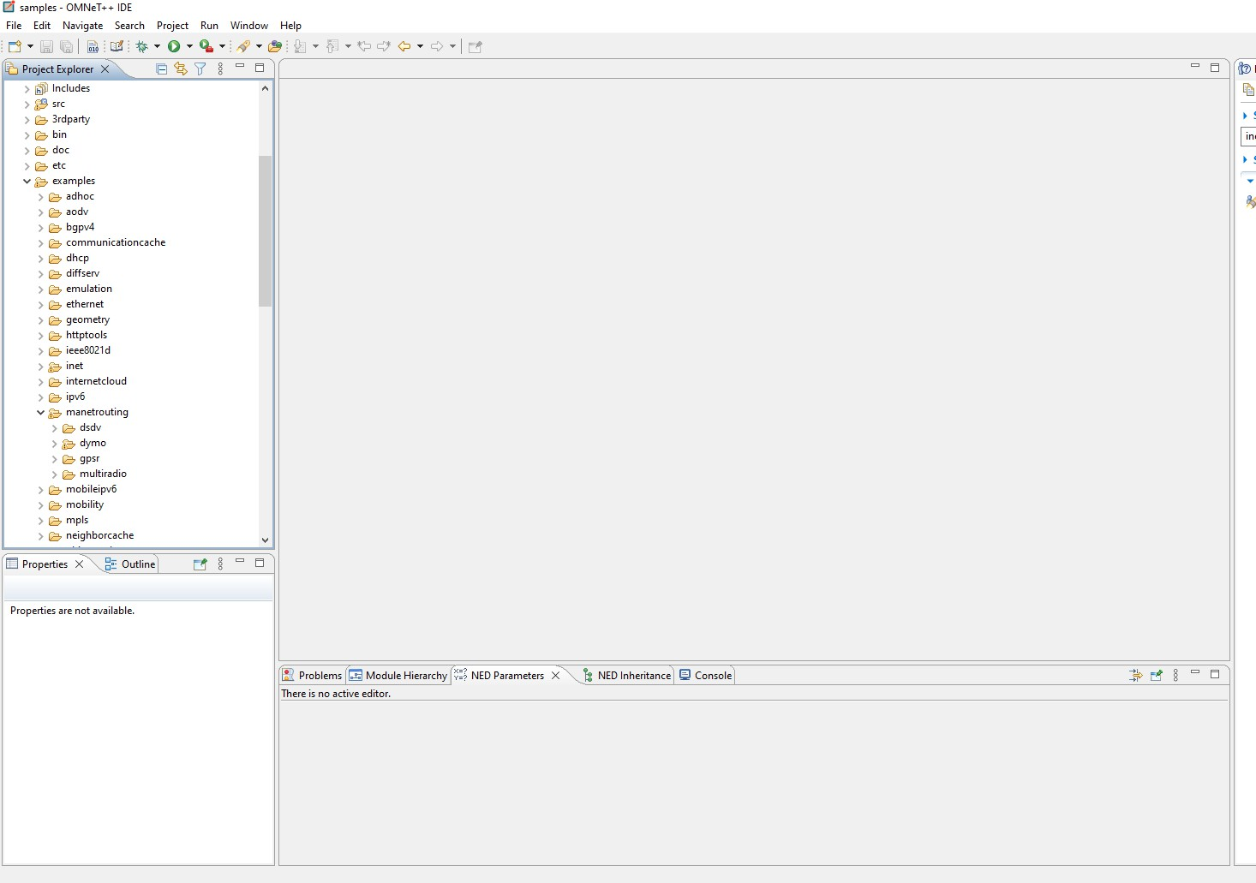

Prof Ismail H. Popatia Page 2

Step 3 : In manetrouting folder click dymo folder and then load the DYMONetwork.ned and omnetpp.ini files by double clicking

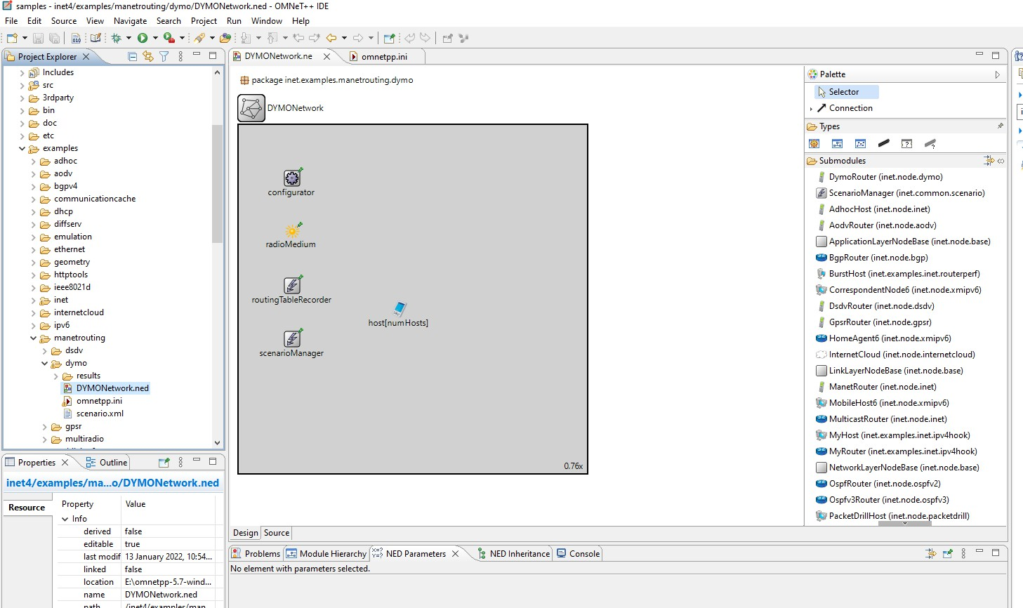

Step 4: Select omnetpp.ini file and click on parameters, we need to add mobility to the nodes

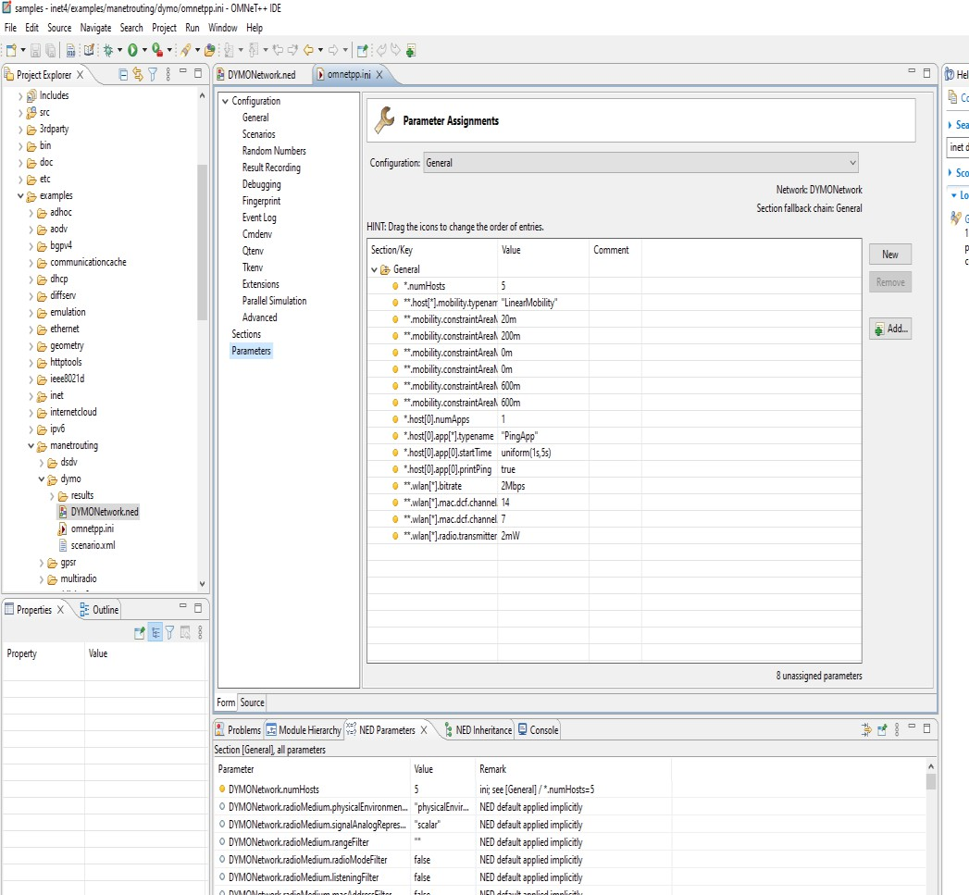

Step 5: For adding a new parameter click on add button and add the parameter

**.mobility.speed

Prof Ismail H. Popatia Page 3

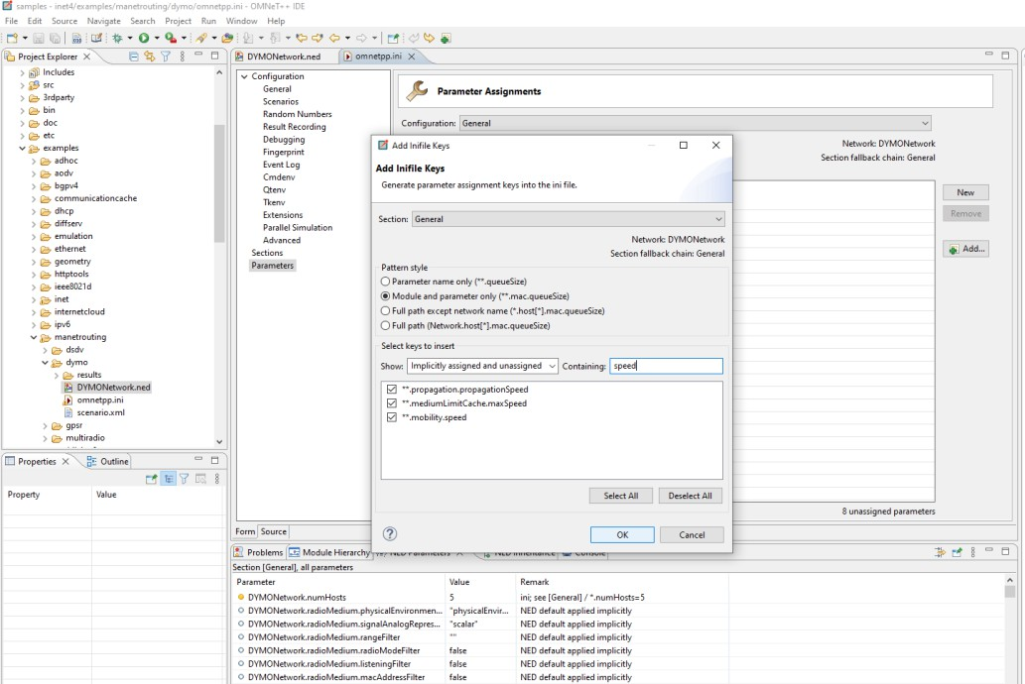

Step 6: Set the value for **.mobility.speed = 400mps

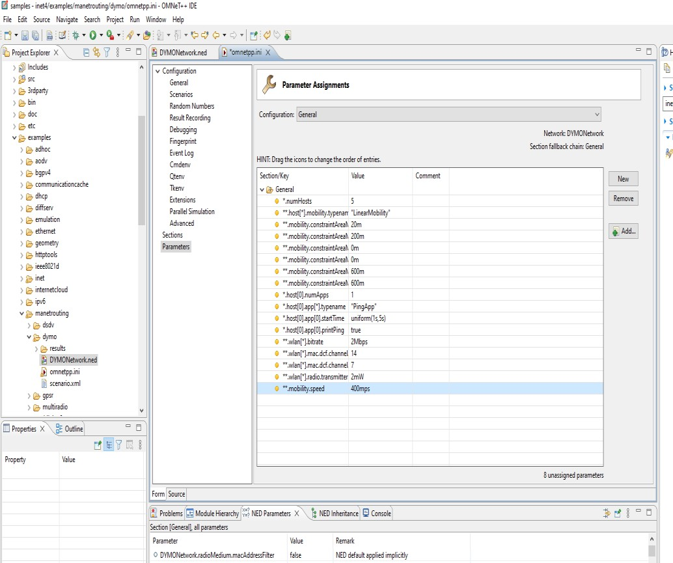

Prof Ismail H. Popatia Page 4

Step 7: Now we run the simulation with 5 mobile hosts forming MANET and get the following output

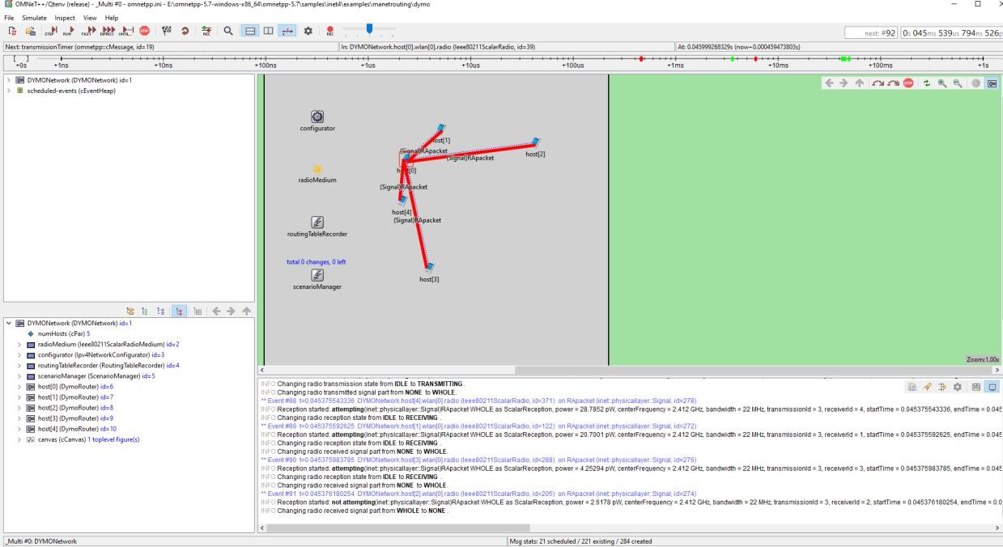

Since the nodes have mobility, after sometime their positions would change and we get

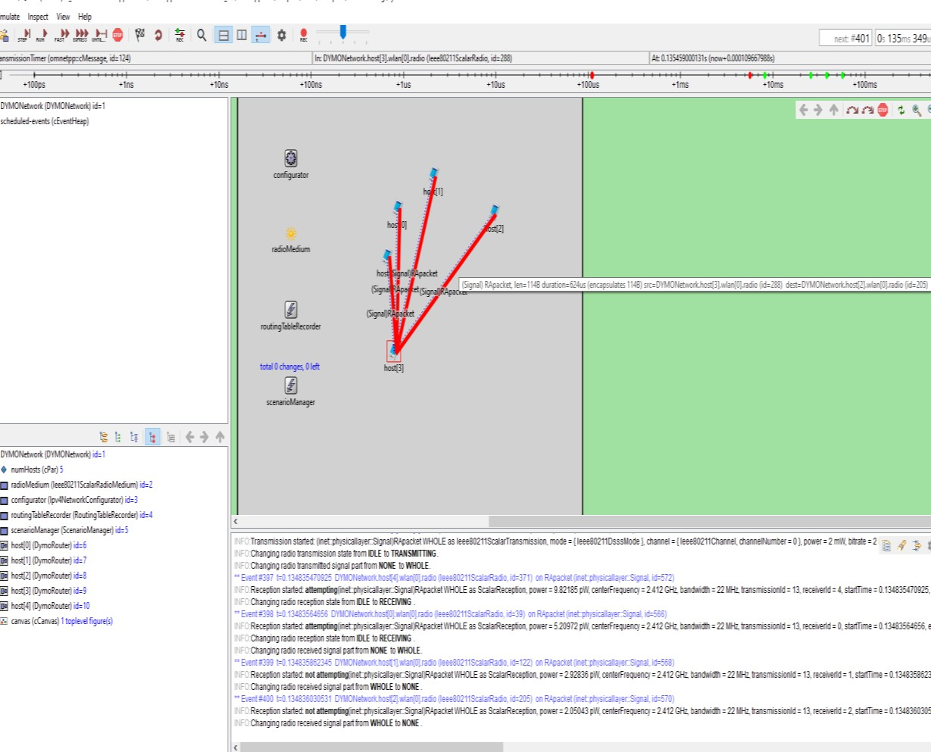

Hence the given MANET has been simulated with 5 hosts

Prof Ismail H. Popatia Page 5

**Practical 5**

**Aim: Implement a Wireless sensor network simulation. Steps:**

1. Create the following network using AccessPoint-PT-A and PC-PT.

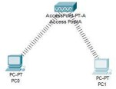

1. Click on PC0 and click on Physical tab.
2. ​Turn off the CPU and remove the FastEthernet module and install PT-HOST-NM-1W-A and turn On the CPU.
3. A connection will be made between Accesspoint and PC0.
4. Click on PC1 and click on physical tab.
5. Repeat step 3 and see if the connection is done between PC1 and Accesspoint.
6. Click on PC0 and set the IP config.

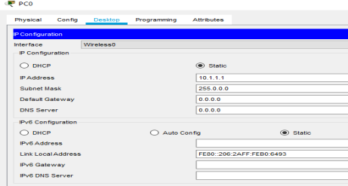

1. Click on PC1 and set the IP config.

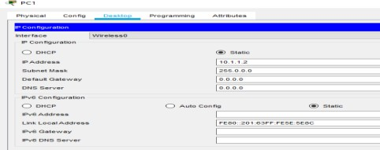

1. Test Access PointA
   1. Ping PC1 (10.1.1.2) from PC0. The ping should succeed.
   2. Ping Laptop0(10.1.1.3) and Server0 (10.1.1.4) from PC0. The pings should fail.
2. Create the following network using Accesspoint-PT, Accesspoint-PT-N, Laptop and Server.

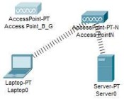

1. Click on Laptop and click on Physical tab.
2. Turn off the Laptop and remove the PT-LAPTOP-NM-1CFE module and install PT-LAPTOP NM-1W and turn On the Laptop.
3. A connection will be made between Accesspoint-PT-N and Laptop.
4. Click on Laptop and set the IP config.

02

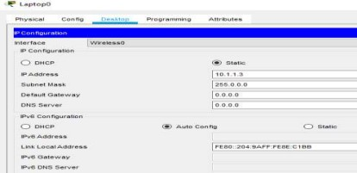

1. Click on Server and click on Physical tab.
2. Turn off the Server and remove the PT-HOST-NM-1CFE module and install PT-HOST-NM-1W and turn On the Server.
3. A connection will be made between Accesspoint-PT-N and Server.
4. Click on Server and set the IP config.

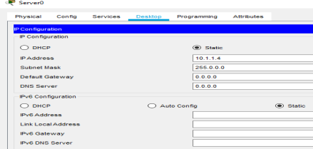

1. Test Access PointN
   1. Ping Server0 (10.1.1.4) from Laptop0. The ping should succeed.
   2. Ping PC0 (10.1.1.1) and PC1 (10.1.1.2) from Laptop0. The pings should fail.
2. Now Turn off the port of AccesspointN and Test Access Point_B_G
   1. Turn on Port1 on Access Point_B_G and turn off Port1 on Access PointN. Laptop0 and Server0 should associate with Access Point_B_G.
   2. Ping Server0 (10.1.1.4) from Laptop0. The ping should succeed.

**Practical – 6**

**Aim: Create MAC protocol simulation implementation for wireless sensor Network. Steps:**

**Create the following network.**

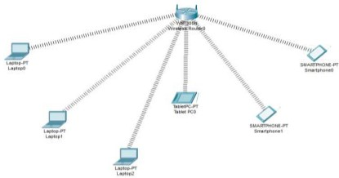

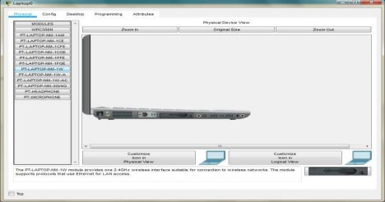**Click on Every laptop and change the interface to PT-LAPTOP-NM-1W.**

**Copy the MAC address of each component as follows**

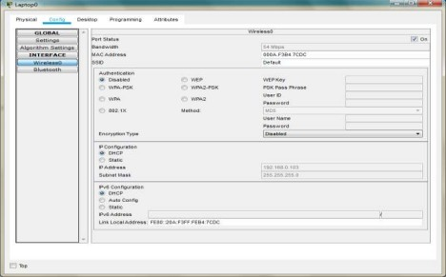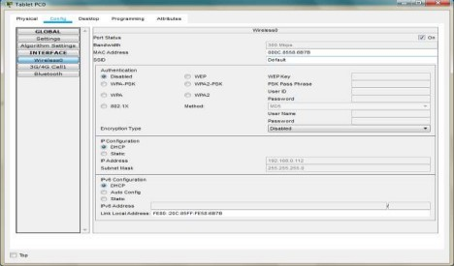

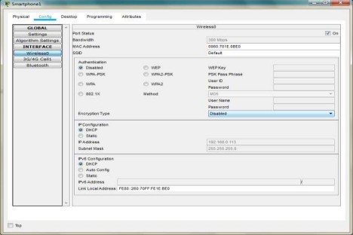

**We note the following MAC addresses and convert them to the following form**

|  |  |  |
| --- | --- | --- |
| **Component** | **MAC Address** | **Converted MAC address** |
| **Laptop0** | **000A.F3B4.7CDC** | **00:0A:F3:B4:7C:DC** |
| **Laptop1** | **0001.4269.6539** | **00:01:42:69:65:39** |
| **Laptop2** | **0060.5CB8.B919** | **00:60:5C:B8:B9:19** |
| **TabletPC** | **000C.8558.6B7B** | **00:0C:85:58:6B:7B** |
| **SmartPhone0** | **00D0.9774.32BD** | **00:D0:97:74:32:BD** |
| **SmartPhone1** | **0060.701E.0BE0** | **00:60.70:1E:0B:E0** |

**Now we add few addresses in the wireless MAC filter of the Wireless Router and then use the given options for either allow or deny the Wireless access**

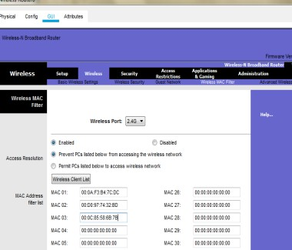

**As seen in above screen shot we add the MAC address of Laptop0, TabletPC SmartPhone0 in the list so as to deny them accessing the Wireless network and then save the settings**

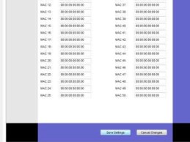

**The result so obtained is as shown, the three devices denied any wireless connectivity**

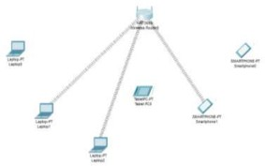

**Similarly we can change the setting so that the above devices get wireless connectivity and the remaining devices do not get the wireless connectivity**

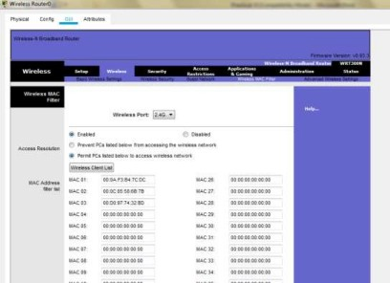

**And save the setting and get the following**

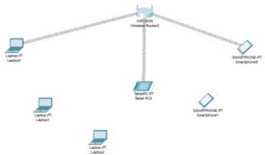

**Practical – 7**

**Aim: Simulate Mobile Adhoc Network with Directional Antenna. Steps:**

**Create the following network.**

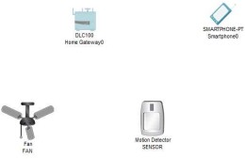

**Click on the Fan and do the following**

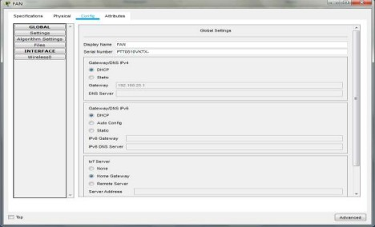

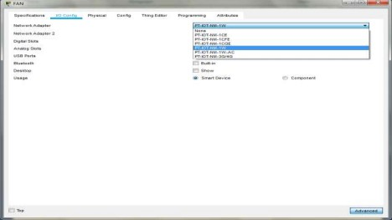

**For the motion Detector sensor do the following**

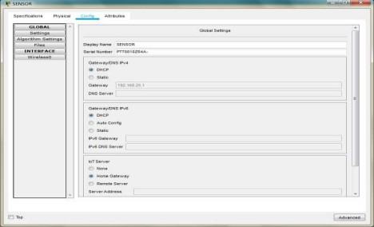

**Select PT-IOT-NM-1W**

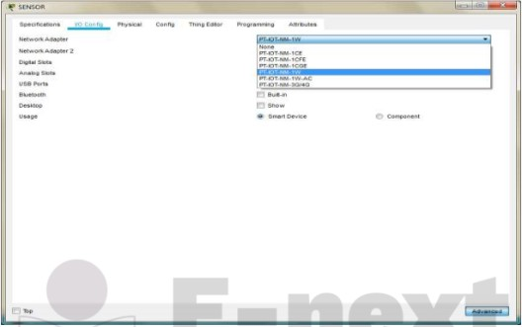

**For the smartphone change the SSID to the SSID in the Home Gateway0**

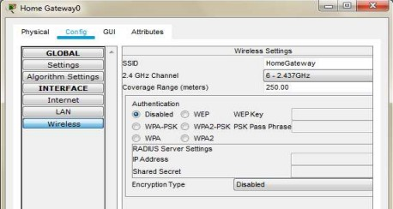

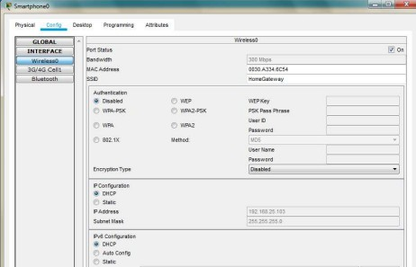

**All the devices are now connected to the Home Gateway**

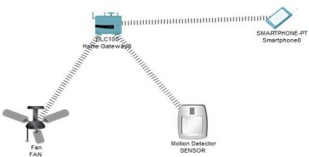

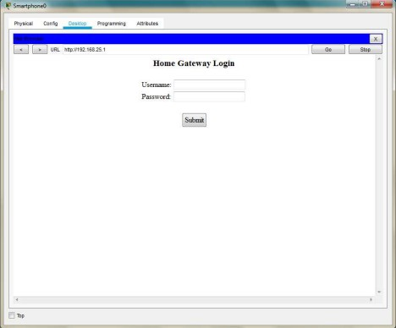

**Username : admin Password : admin**

**After logging click on conditions and do the following**

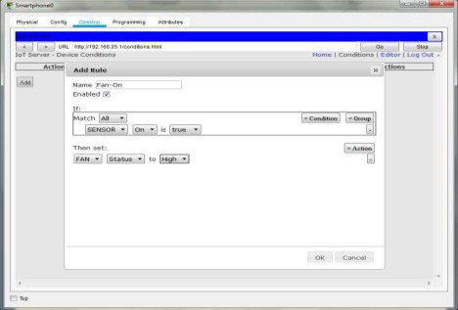

**Add another condition as follows**

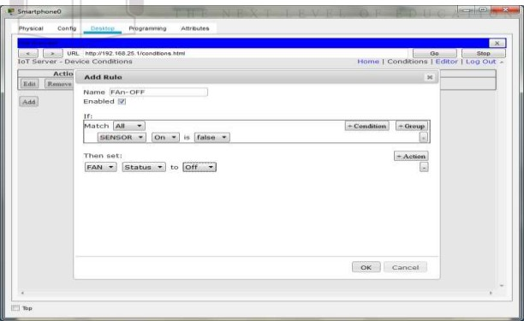

**Press the go button after adding the two conditions**

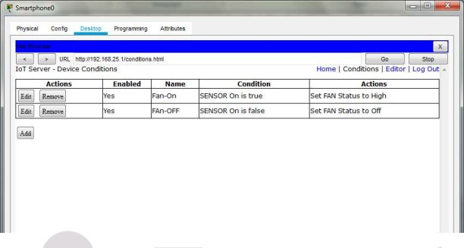

**In order to turn ON the fan Press the ALT key and left-click the mouse over the Sensor**

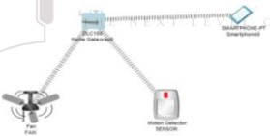

# Create a mobile network using Cell Tower, Central Office Server, Web browser and Web Server. Simulate connection between them.

## Aim:

To create a mobile network using Cell Tower and other components and simulate the connection between them

## Software Used:

Cisco Packet Tracer 7.2.0.026

## Theory:

Consider the following topology

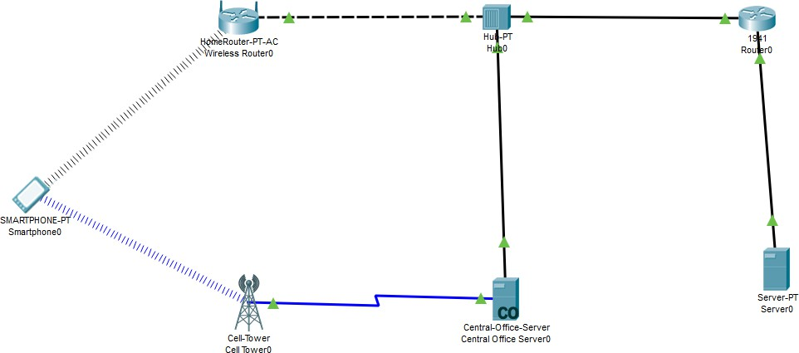

We create the above topology using the Cisco packet tracer

Prof Ismail H. Popatia Page 1

IP address configuration is done for the following devices

1. Router 0:
   1. Interface: FastEthernet0/0:

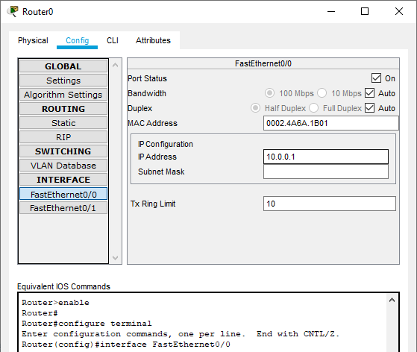

* 1. Interface: FastEthernet0/1:

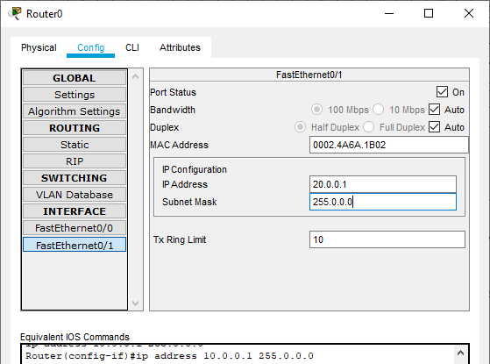

Prof Ismail H. Popatia Page 2

1. Wireless Router:

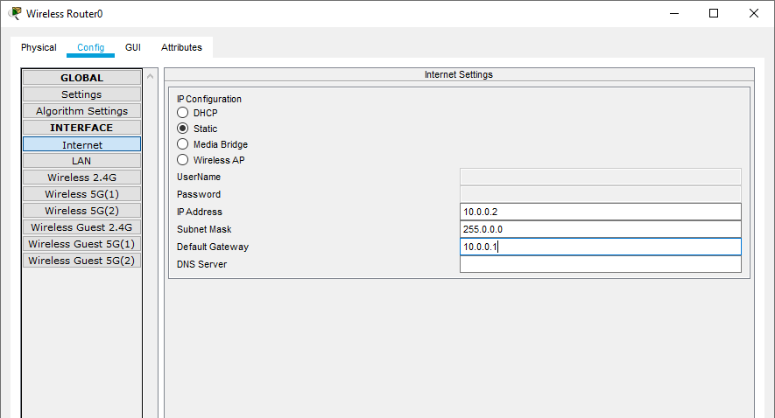

1. Smartphone:

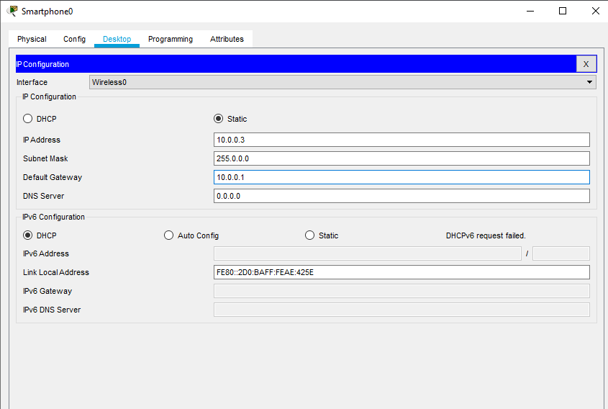

Prof Ismail H. Popatia Page 3

1. Server:

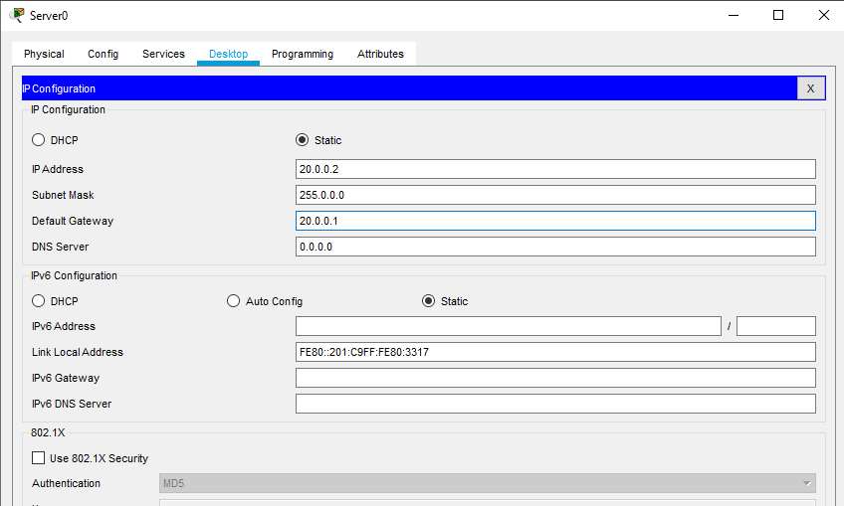

Next we verify the network connectivity as follows

1. Send a ping message from smartphone to server

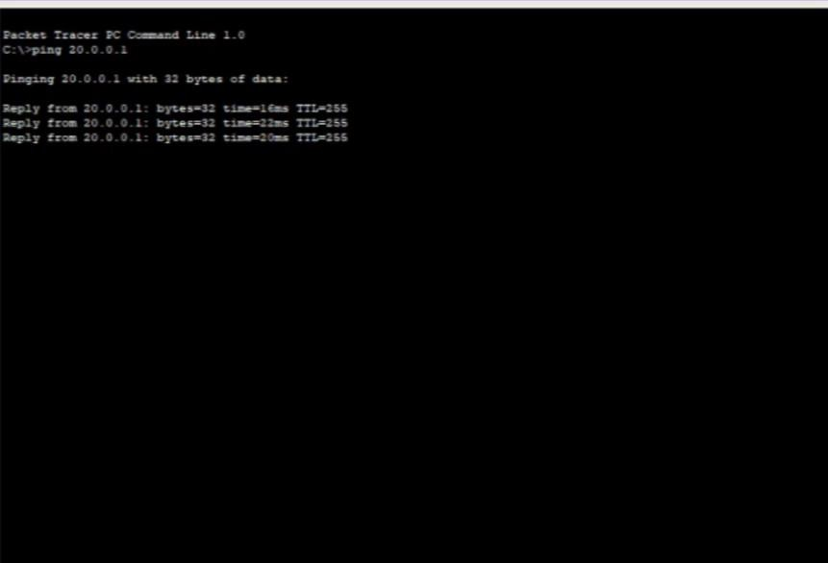

Prof Ismail H. Popatia Page 4

1. Access the web service from the server through the Smartphone

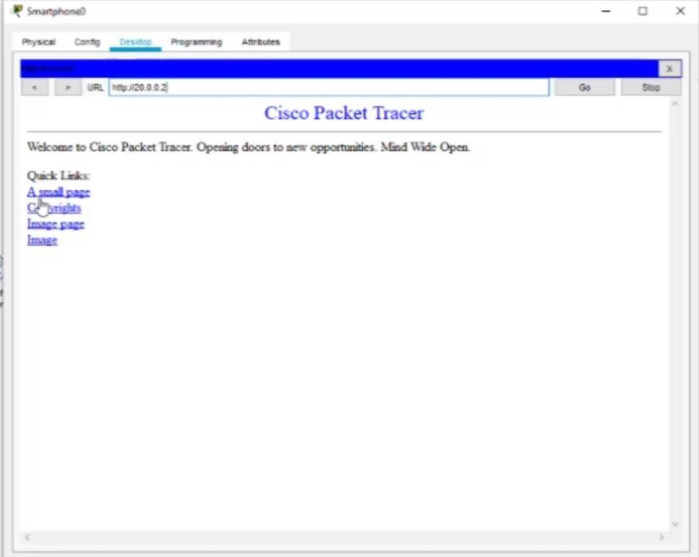

Hence the mobile network was created and connectivity was also verified

Prof Ismail H. Popatia Page 5